DESCRIBE THE PRINCIPLE OF OPERATION OF A SYNCHRONOUS MOTOR.

SYNCHRONOUS MOTOR:

The synchronous motor is so called because its rotor turns in synchronisation with the rotating field set up by the stator. You know that the application of three phases A.C. to the stator causes a rotating magnetic field to be set up around the rotor.
But since the rotor of a synchronous motor is energised with D.C. it will act like a bar magnet. If a bar magnet is suspended in a magnetic field, it will turn until it lines up with the magnetic filed.

Principle of Operation of a Single Phase Synchronous Motor.

Now you will see how single-phase A.C. applied to a stator winding will produce a pulsating magnetic field, which can also be used to drive a motor.
Every time a rotor pole approaches a stator winding, the direction of the stator filed must be such as to attract the pole, and to give it torque in the direction of its motion. So the filed current in a stator winding must pass through half a cycle in the interval between rotor poles of opposite polarity approaching the winding.

The diagram below indicates the direction of the stator filed created by the application of a single-phase A.C.
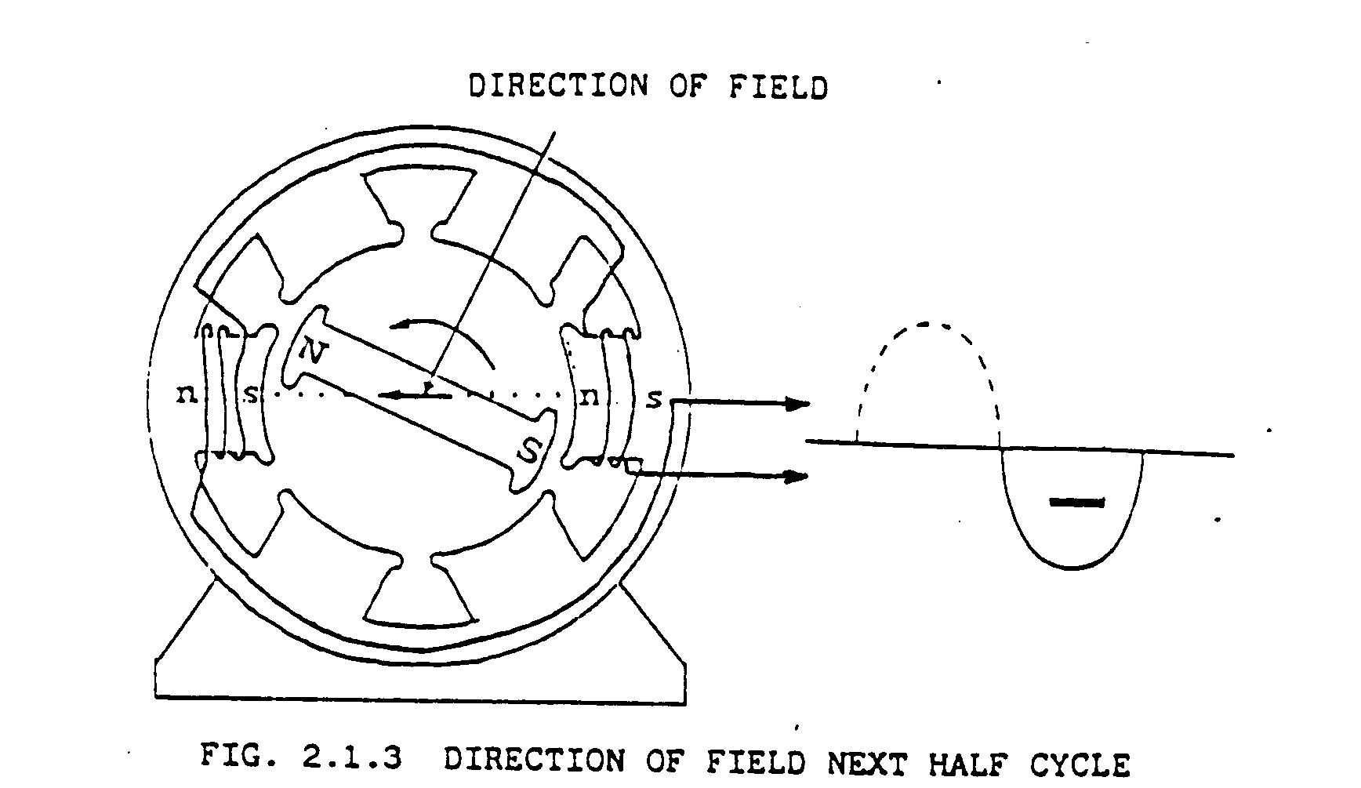The illustration above shows one half cycle: and you will see that, as the rotor lines itself up with the stator filed, its poles are being attracted by the windings of the stator.

In the illustration above, you can see that in the next half cycle, the stator field is reversed; and the momentum, which the rotor has acquired, has turned it through 180°.
Then, once again as the rotor poles approach the stator winding, there is a force of attraction, which keeps the rotor moving in the desired direction.

NOTE:

The single-phase A.C. synchronous motor needs a starting device to give the rotor movement in the desired direction.

Small single-phase synchronous motors may use permanent-magnet rotors, which do not have field windings nor require D.C to be applied to them.

Principle of Operation of a Three-Phase Synchronous Motor

The synchronous machine is so called because its rotor is synchronised with the rotating field set up by the stator.
The rotor of a synchronous motor is energised with a D.C. The rotor acts like a magnet and is attracted by the rotating stator field. This attraction exerts a torque on the rotor and causes it to rotate with the rotating filed. The position of the rotor of a two-pole machine at various positions during one cycle of the three phase A.C. stator supply is shown in Figure 2.2.1.

It should be clear that the rotor turns with the magnetic filed.

One of the disadvantages of a synchronous motor is that it cannot be started from standstill by applying three-phase A.C. to the stator.

The instant A.C. is applied to the stator, high-speed rotating filed appears. This rotating field rushes past the rotor poles so quickly that the rotor does not have a chance to get started; it is in fact replied first in one direction and then in the other.
In other words, a synchronous motor in its pure form has no starting torque.

Synchronous motors are therefore started , with the help of a small induction motor, or with windings equivalent to this incorporated in the synchronous motor.

When the rotor has been brought near to synchronous speed be the staring device, it is energised by connecting it to a D.C. voltage source. The rotor then falls into step with the rotating field.

You will learn more about starting of a synchronous motor later on in this manual.

Armature Windings

The armature windings of an A.C. machine (this term includes synchronous and induction motors) are usually arranged on the stator. The armature windings of A.C. machines are similar to the stator windings of a generator.
Figure 2.2 shows a simplified structure of a six-pole synchronous machine. The structure shows three armature coils of one phase only. The armature (stator) of figure 2.3.1 has three slots per pole, this corresponds to one slot per phase and pole for the three phase winding.
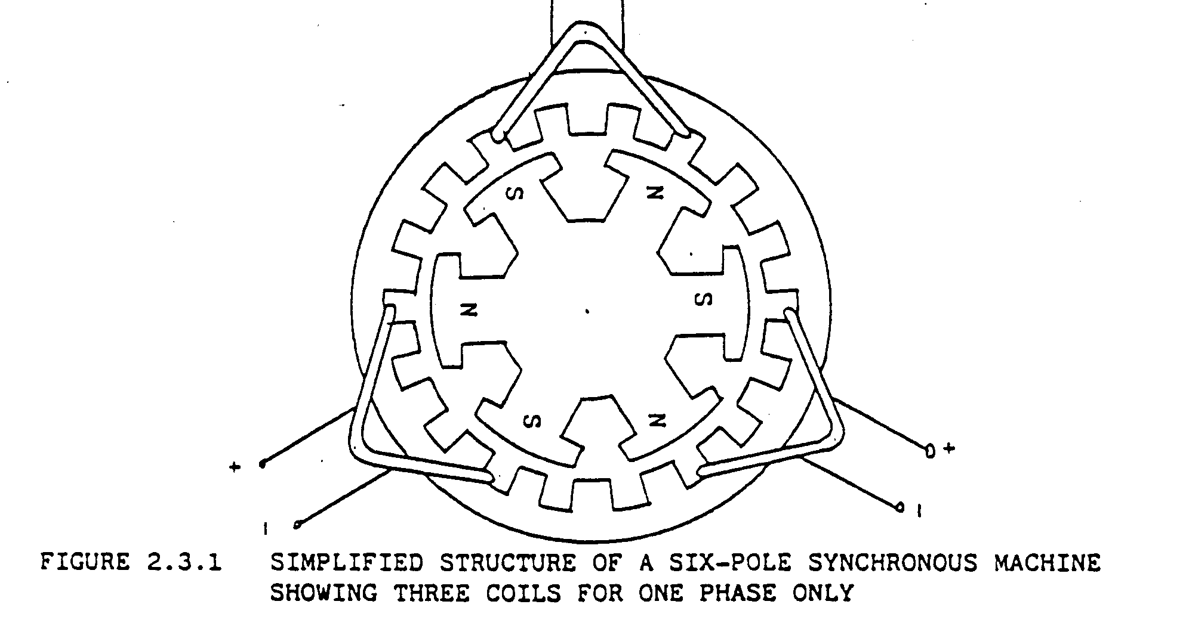
Field Winding

In contrast with the D.C. machine, the field windings of conventional synchronous machines are generally carried by the rotor. The advantage of having the field winding on the rotor are the following:

a) The field winding is smaller than the armature winding.

- It operates at a lower voltage and smaller current. The stator (armature) connections, which are normally high voltage, are thus easier to isolate.

c) The field winding is excited with direct current, thus requiring only two slip rings. If the armature windings were on the rotor they would require at least three slip rings.

Rotor Construction and Winding

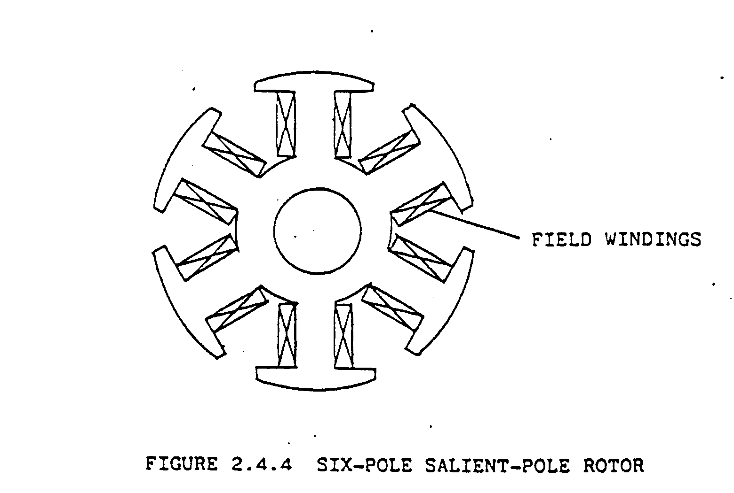Depending on the construction of the armature, synchronous machines fall into two general classifications, cylindrical-rotor machines and salient-pole machines. As only salient-pole motors are used on Impala mines, we will only look at this type of construction. Figure 2.4.4 shows the construction of a 6-pole salient pole rotor. The salient - poles are carried on a rotor body and the field coils are placed over these poles.

Field Excitation

Because a D.C. source is necessary for the excitation of the rotor field, an exciter is usually used. The exciter is often coupled to the motor shaft and it delivers the required field excitation.

Speed of Synchronous Motors

As mentioned earlier the synchronous motor runs at a constant speed. In the previous section it was mentioned that the rotor turns with the rotating field. As this rotating field is set up by the three phase A.C. supply we can say that the rotor speed depends on the frequency of the supply voltage.
Another factor which determines the rotor speed is the number of poles that the field windings have.

Possibility of having a Leading Power Factor

Since the filed of the synchronous motor is externally excited it is possible to over excite the filed. a synchronous motor with an over excited field has a leading power factor. Due to this possibility of having a leading power factor the synchronous motor can be used for power factor improvement. To describe this let’s consider the following:

Consider the electricity consumption of a mine. Since most of the large machinery such as the winders (D.C. winders indirectly) and reciprocating compressors (our damage compressors are driven by synchronous motors) are driven by induction motors the lagging power factor of each motor reduces the power factor of the network. If a synchronous motor with over excited field is now used to drive for example a M.G. set or a Demag compressor, its leading power factor would improve the power factor of the network. Thus by having a good power factor, less power is wasted and money is saved.

Thus apart from having a constant speed, the synchronous motor can be used for power factor improvements.

Starting of a Synchronous Motor

One of the disadvantages of a synchronous motor is that it cannot be started from standstill by applying A.C. power to the stator.

The instant the A.C. is applied to the stator, the rotating field appears. This rotating field rushes past the rotor pole so quickly that the rotor does not have a chance to react on the field to get started. Therefore to start a synchronous motor the motor must be brought up to near synchronous speed before the field is excited and the motor pulls into steps with the rotating field.
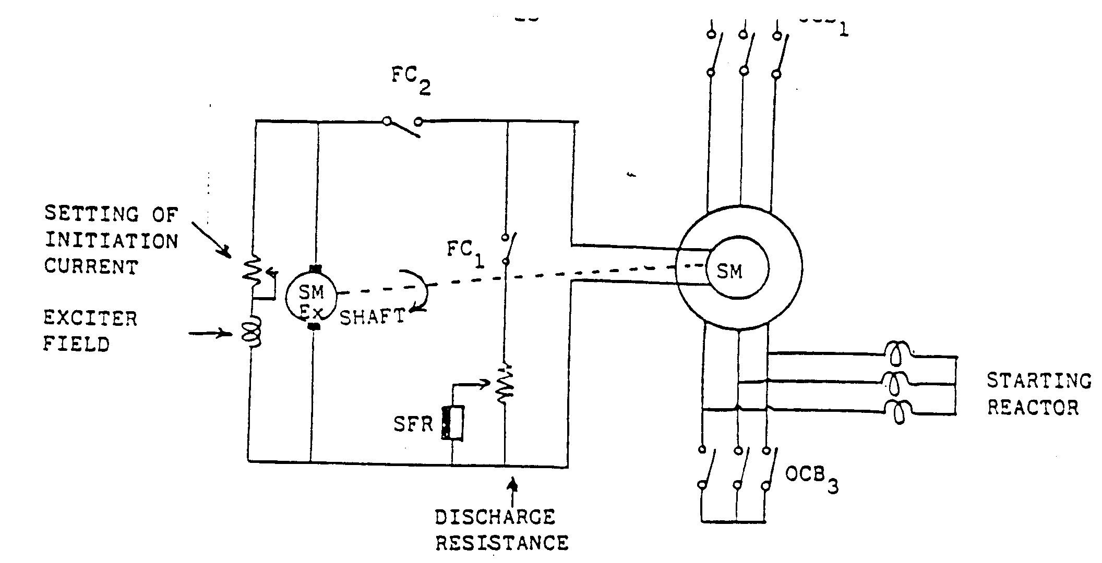
A method to start the synchronous motors is called reactor starting. As this method is used on Impala Mines, lets consider its operation. Figure 2.7.1 is simplified diagram of the reactor starting method.
When starting, OCB is open and the starting reactor is in series with each of the motor phases. The purpose of the starting reactor is to reduce the voltage and thus the line current at starting. The reactor starter can be placed on the neutral side as indicated, or sometimes (often) on the line side.
When starting the synchronous motor the field winding is short-circuited through a discharge resistor.
When the motor reaches a certain speed the Slip Frequency Relay (SFR), is energised and this causes the filed contacter (FC), to energise and OCBcloses. When the FC is energised contact FC opens and contact FC closes, thus the short-circuit discharge resistance is removed and the field is excited with D.C. supplied by the exciter. When OCB closes the reactor is short -circuited and the full voltage is applied to the motor. often for starting is used, e.g. on 4500 HP winders.

Advantage and Disadvantage of Synchronous Motors

Advantage of Synchronous Motors

a) Deliver constant speed over a wide range of load torque.
b) Can be used for power factor improvement.

Disadvantages of Synchronous Motors

a) Lack of flexible speed control.
b) It requires a D.C. source for its field excitation.
c) Not self Starting.
d) Are much more expensive than induction motors.
e) Worst problem: rotor problems.

